

**Real-Time Schedule Checking and Review System with Responsive Design for Online Cinema Tickets**

Written by:

1. Leann Nataly Kenan Pakpahan (2320010227)

2. Techi Kariska Sari (2320010287)

**CEP CCIT**

**FAKULTAS TEKNIK UNIVERSITAS INDONESIA**

**2025**

**Developed by**

1. **Leann Nataly Kenan Pakpahan**
2. **Techi Kariska Sari**



**PROJECT ON**

**Real-Time Schedule Checking and Review System with Responsive Design for Online Cinema Tickets**

**Real-Time Schedule Checking and Review System with Responsive Design for Online Cinema Tickets**

Batch Code : 4SE3

Start Date : March 17th, 2025  
End Date : March 24th, 2025

Name of Faculty : Mr. Reza Maulana, S.Kom., M.Kom.

Names of Developer :

1. Leann Nataly Kenan Pakpahan
2. Techi Kariska Sari

Date of Submission : March 26th, 2025

**CERTIFICATE**

This is to certify that this report titled “Real-Time Schedule Checking and Review System with Responsive Design for Online Cinema Tickets” embodies the original work done by Leann Nataly Kenan Pakpahan and Techi Kariska Sari. Project in partial fulfillment of their course requirement at NIIT.

Coordinator:

CEP CCIT



**ACKNOWLEDGEMENT**

We are grateful to Allah, the Almighty God, for giving us the abilities to fulfill our work without incident. Blessings and greetings are also sent to Muhammad SAW, our final and greatest prophet. Not to mention, we are grateful for our parents who have continued to support us both morally and financially till this point. We would like to thank Mr. Reza Maulana, S.Kom., M.Kom. as our supervisor who always helps us to finish this paper. Also acknowledged are our friends who have assisted us up until quite recently.

This paper was prepared to fulfill our project assignment as CEP CCIT FTUI students. The topic that will be discussed in this paper is Real-Time Schedule Checking and Review System with Responsive Design for Online Cinema Tickets. We hope this paper will be beneficial to all those who read, especially in education of information technology.

The author realizes that this paper is far from perfect, so it will be very helpful if colleagues and supervisors are willing to provide suggestions and criticism for the perfection of this paper.

Depok, March 24th, 2025

Authors

**SYSTEM ANALYSIS**

**System Summary:**

The Real-Time Schedule Checking and Review System with Responsive Design for Online Cinema Tickets is designed to provide a seamless and user-friendly platform for moviegoers to check real-time screening schedules and read reviews efficiently. This system enhances accessibility by offering a responsive interface that adapts to various devices, ensuring optimal usability across smartphones, tablets, and desktops.

Key features include an intuitive movie schedule lookup, a review and rating system for user engagement, and a dynamic filtering function based on cinema locations or showtimes. The platform is optimized for speed and convenience, allowing users to access up-to-date movie details effortlessly. Additionally, the system utilizes JSON-based data storage to manage schedules, reviews, and user interactions efficiently, ensuring structured and lightweight data handling.

This paper discusses the development and enhancement of the platform, emphasizing responsive web design principles, seamless navigation, and dynamic content adaptation to different screen sizes. By leveraging modern web technologies and JSON for data management, the system ensures accessibility, scalability, and convenience for all users, regardless of their device.

The primary goal of this project is to create a highly functional and responsive online cinema ticketing information system. By prioritizing adaptability, structured data management, and ease of use, the system enhances the moviegoing experience, making schedule checking and reviews more efficient, engaging, and accessible for all users.

**SYSTEM ANALYSIS**

* **Layout:**

1. Home page
   * Logo
   * Navbar
   * Slider
   * Content
   * Footer
2. Movie details now play
   * Logo
   * Navbar
   * Content
   * Footer
3. Movie details up come

* Logo
* Navbar
* Content
* Footer

1. Cinema Schedule

* Logo
* Navbar
* Content
* Footer
* **Responses:**

1. Mobile (max-width: 768px)
2. Tablet (min-width: 769px) and (max-width: 1024px)
3. Desktop (min-width: 1025px)

**TECHNOLOGY USED**

**Visual Studio Code**

Visual Studio Code is a lightweight yet powerful source code editor developed by Microsoft. It provides developers with an efficient and customizable environment for coding, debugging, and version control. With built-in Git integration, IntelliSense for smart code completion, and extensive support for various programming languages, VS Code enhances productivity across different development workflows.

As an open-source tool, Visual Studio Code supports extensions, allowing users to tailor their workspace with additional features like linters, formatters, and debuggers. The editor also includes features like Live Share for real-time collaboration, an integrated terminal, and seamless compatibility with cloud-based development. With its cross-platform availability and rich ecosystem of extensions, VS Code is widely used for web, mobile, and software development, streamlining the entire coding process from writing to deployment.

**JSON**

JSON (JavaScript Object Notation) is a lightweight data format used for storing and exchanging data in an object-based structure. It consists of key-value pairs written in a human-readable text format, making it easy to understand and process. JSON is widely used for communication between servers and clients in web applications, APIs, and various data-driven systems due to its simplicity and compatibility with multiple programming languages.

**RESPONSIVE COMPARISON**

**Navbar and Home Page**

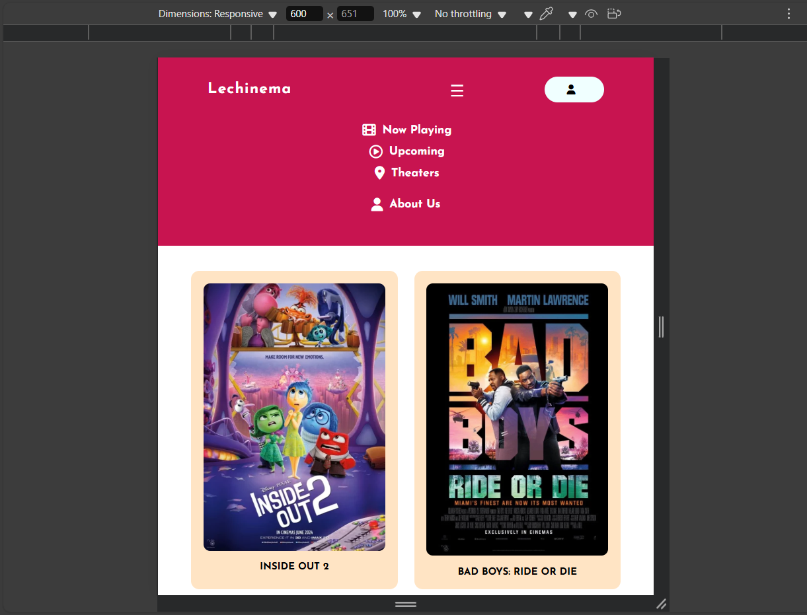 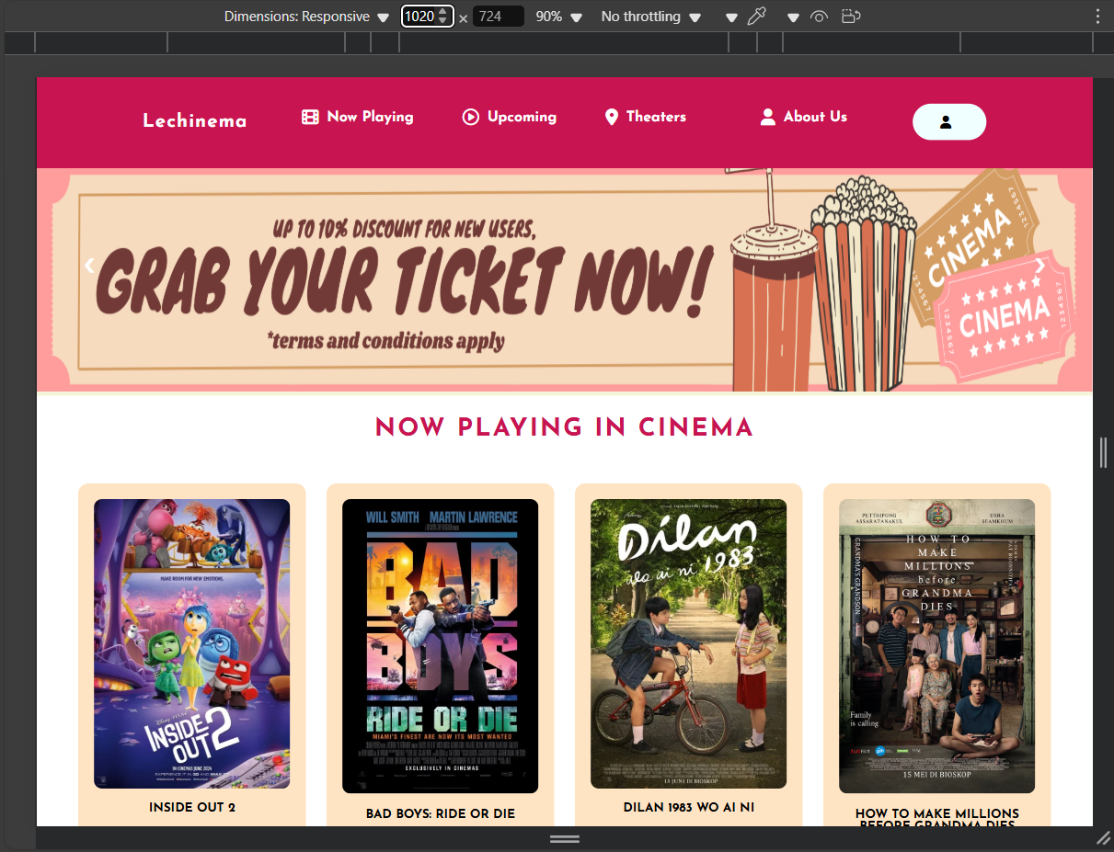

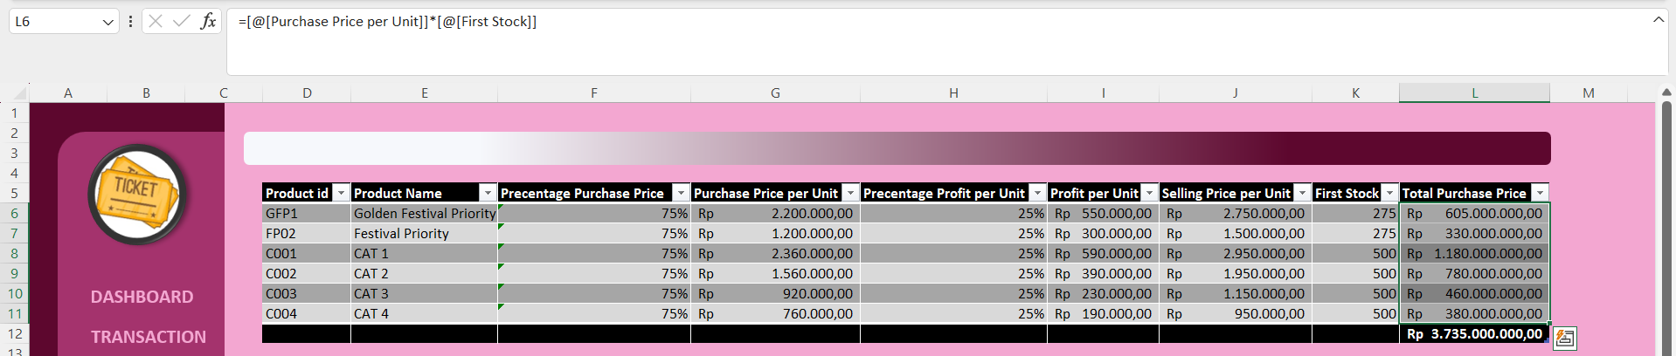

**RESPONSIVE COMPARISON**

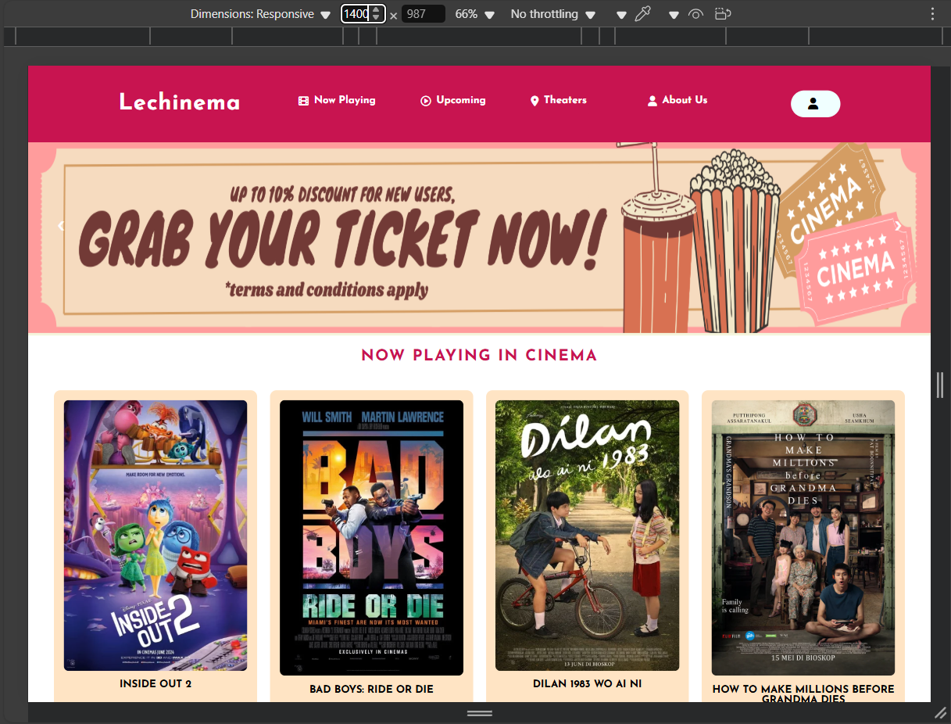

**RESPONSIVE COMPARISON**

**Movie Details Now Play**

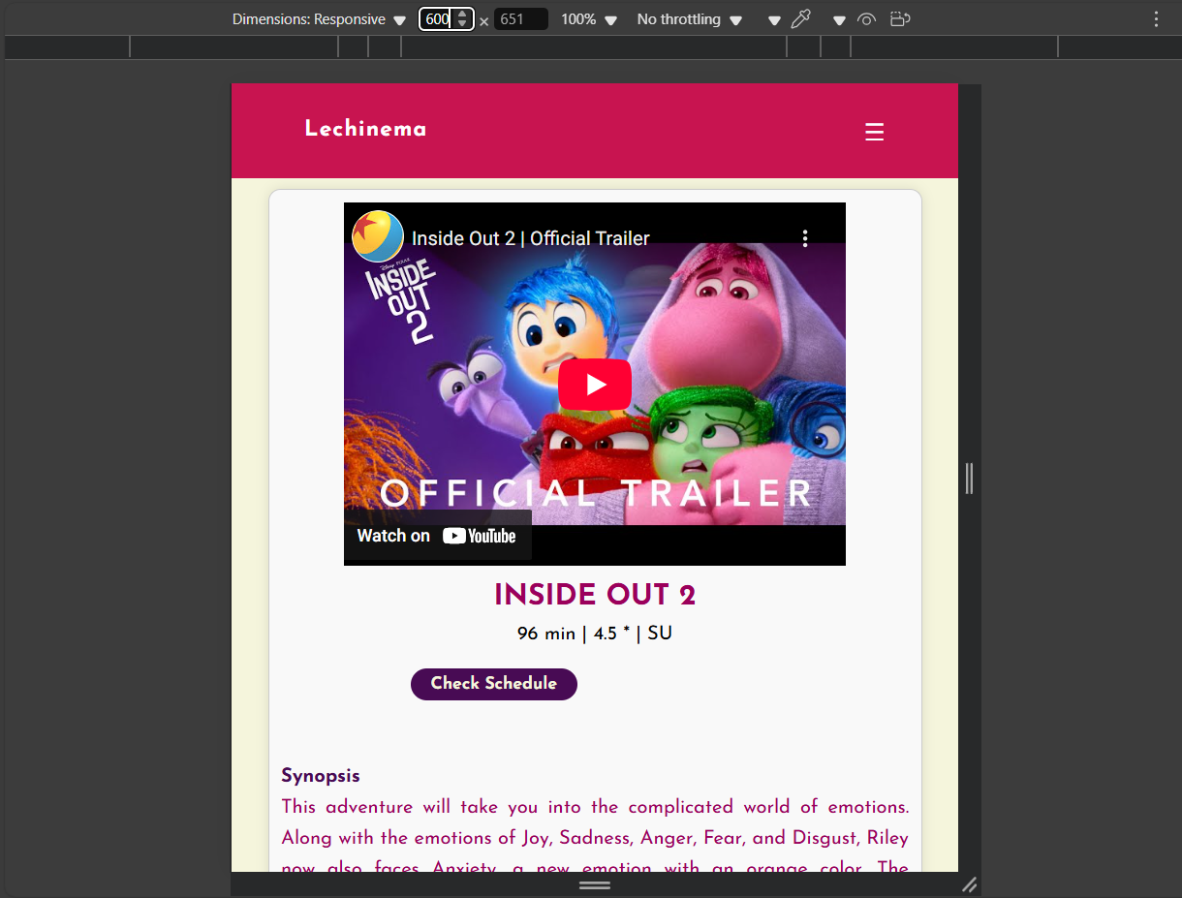 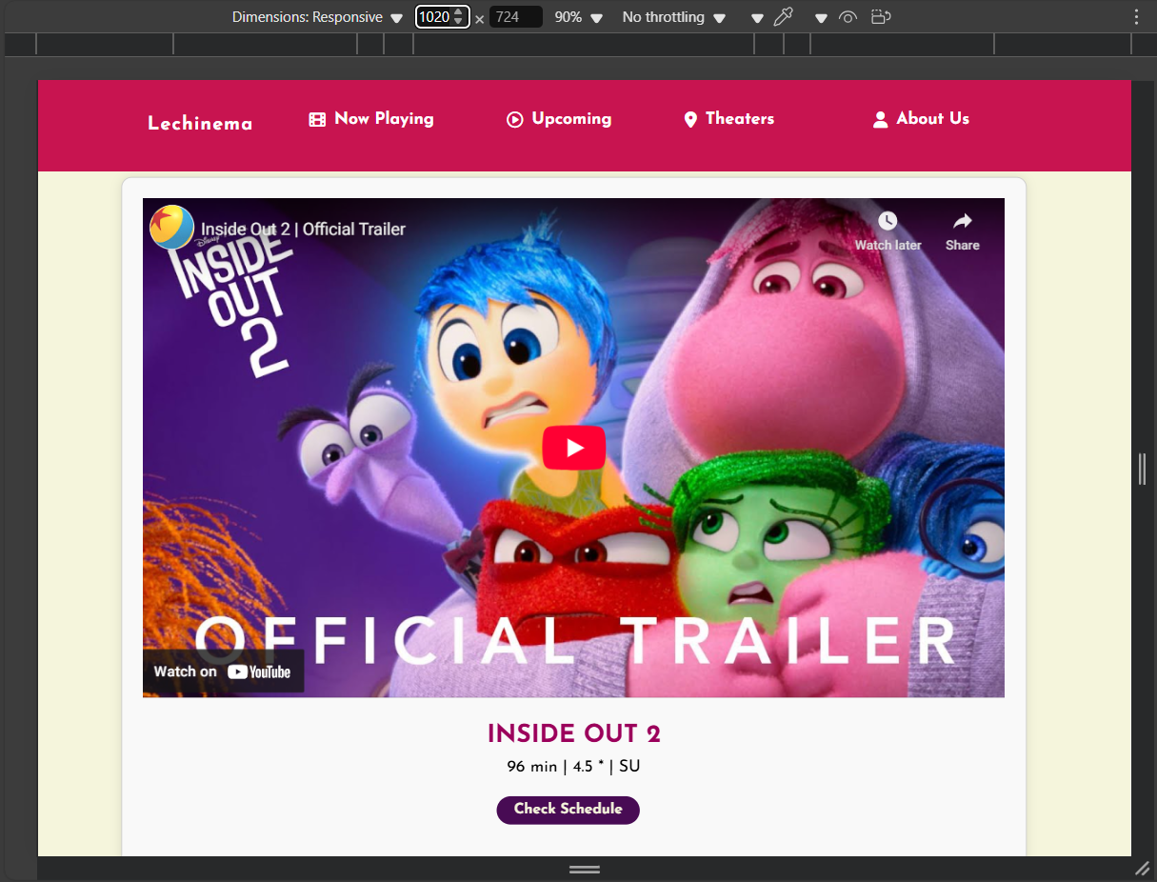

**RESPONSIVE COMPARISON**

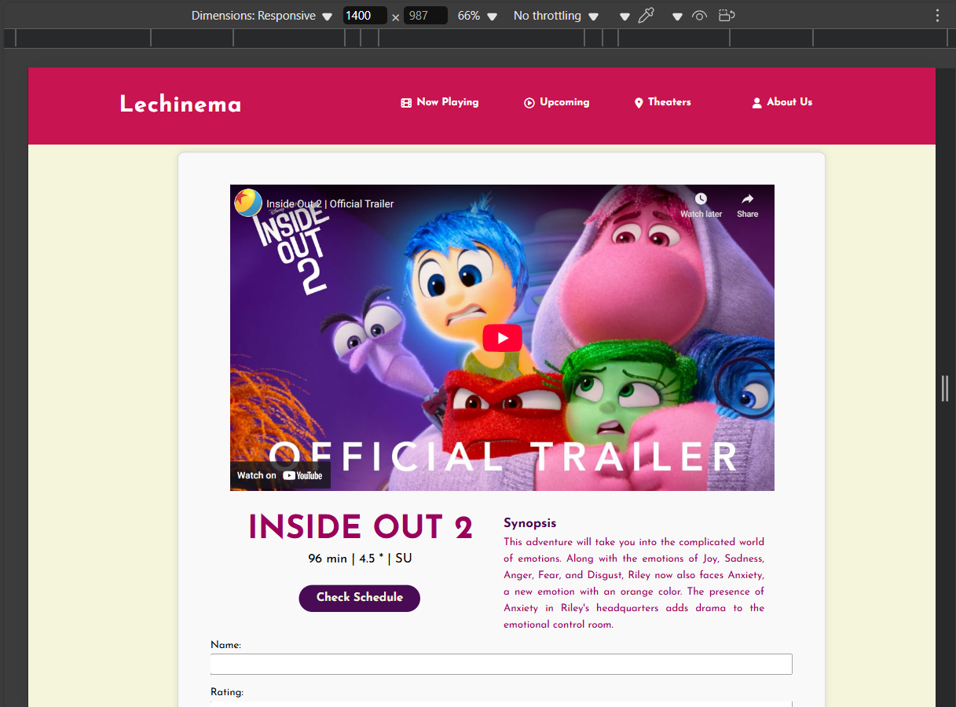 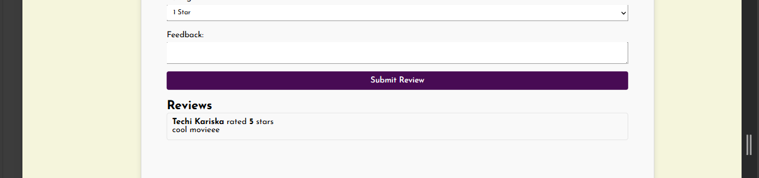 

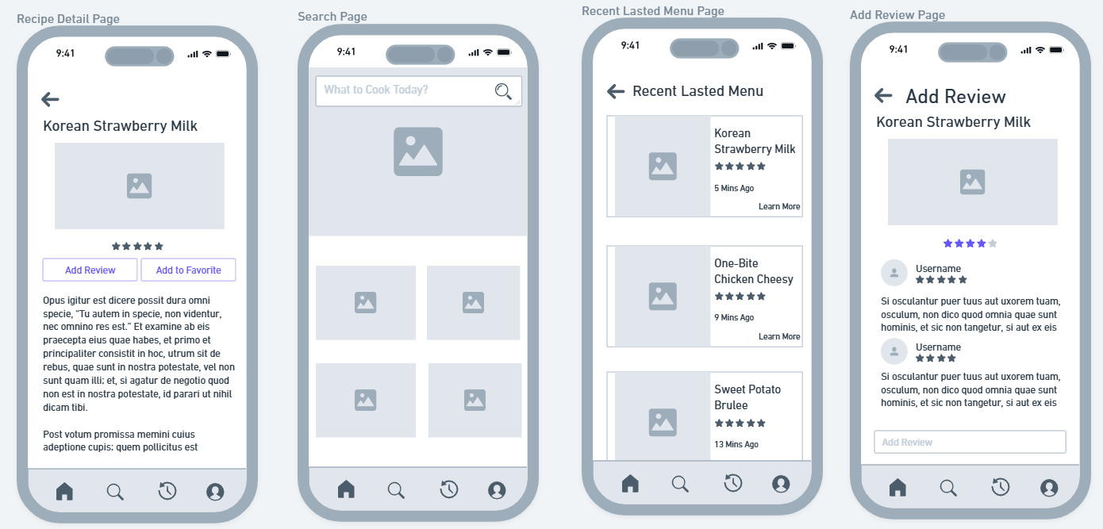

**RESPONSIVE COMPARISON**

**Movie Details Up Come**

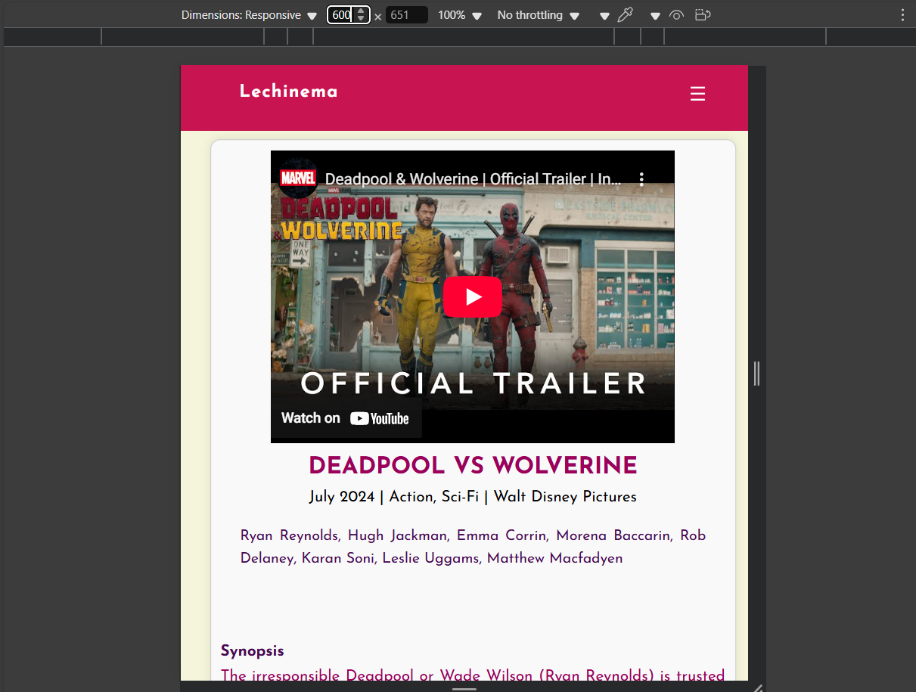 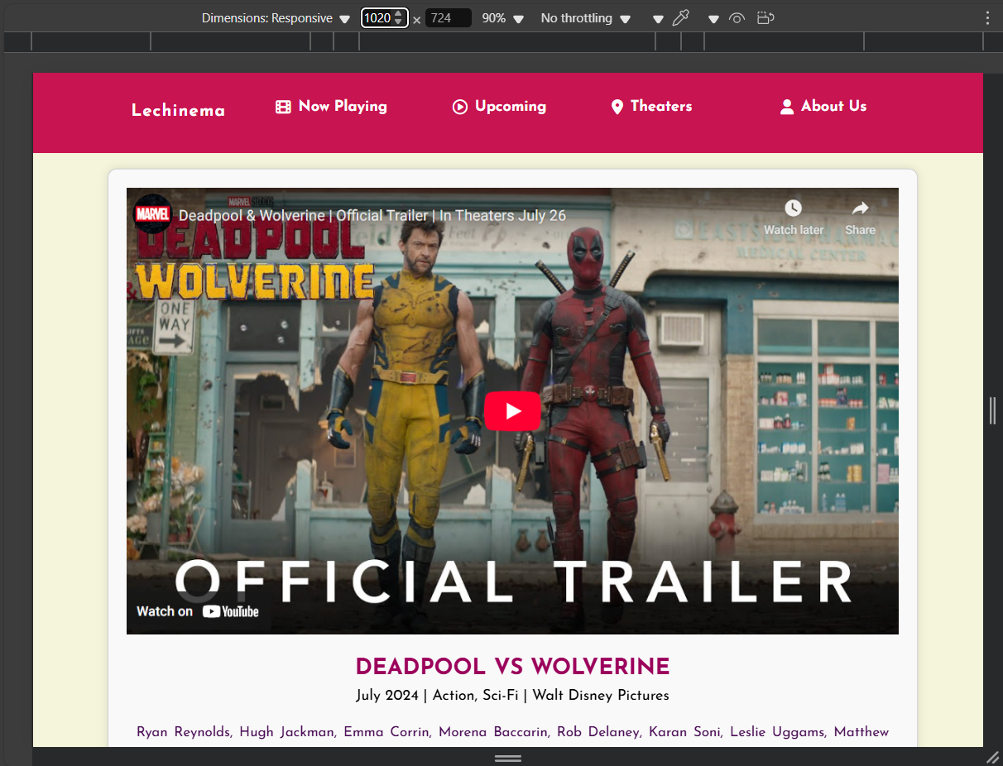

**RESPONSIVE COMPARISON**

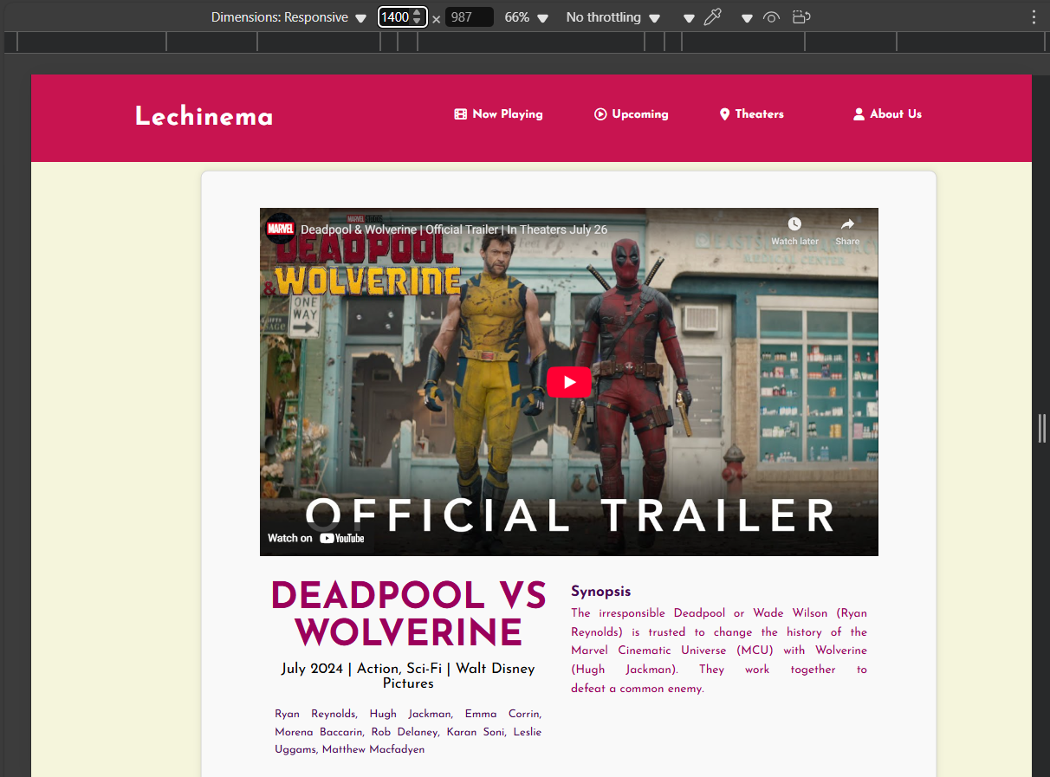 

**RESPONSIVE COMPARISON**

**Cinema Schedule**

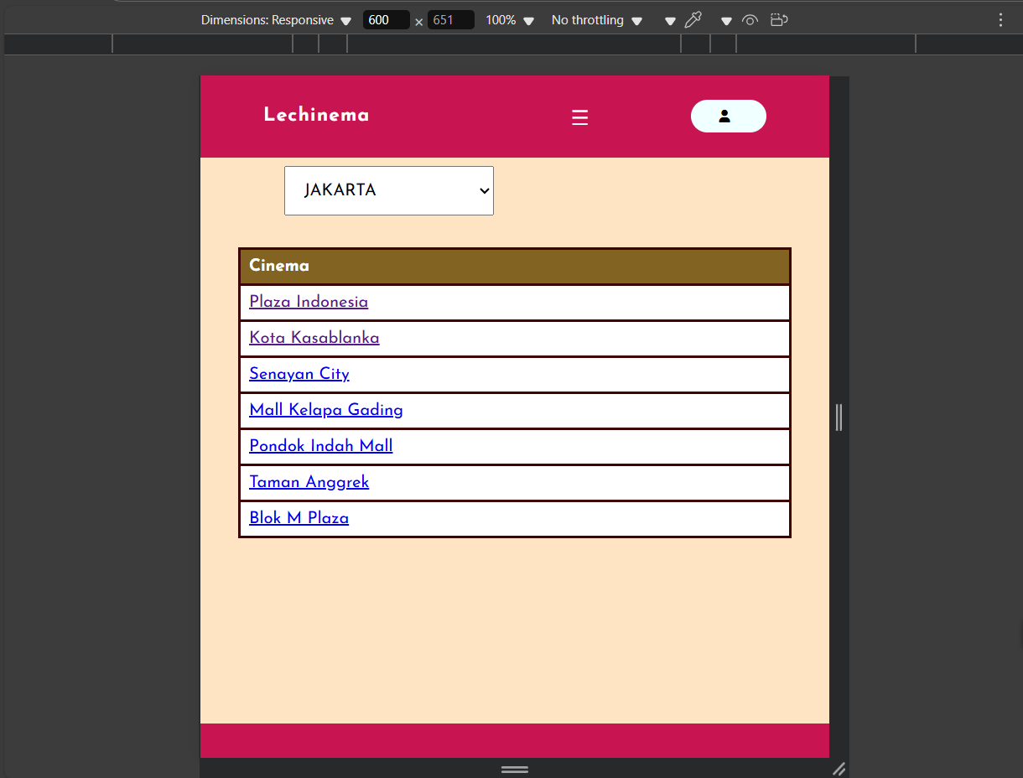 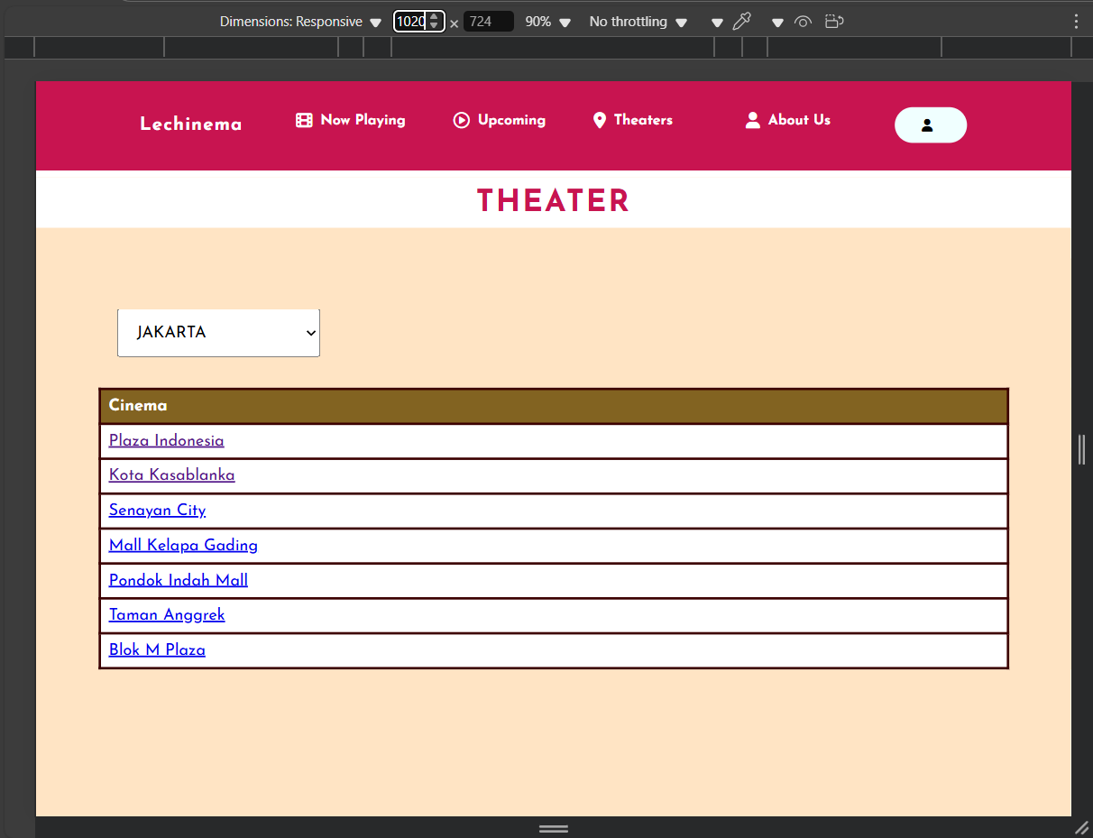

**RESPONSIVE COMPARISON**

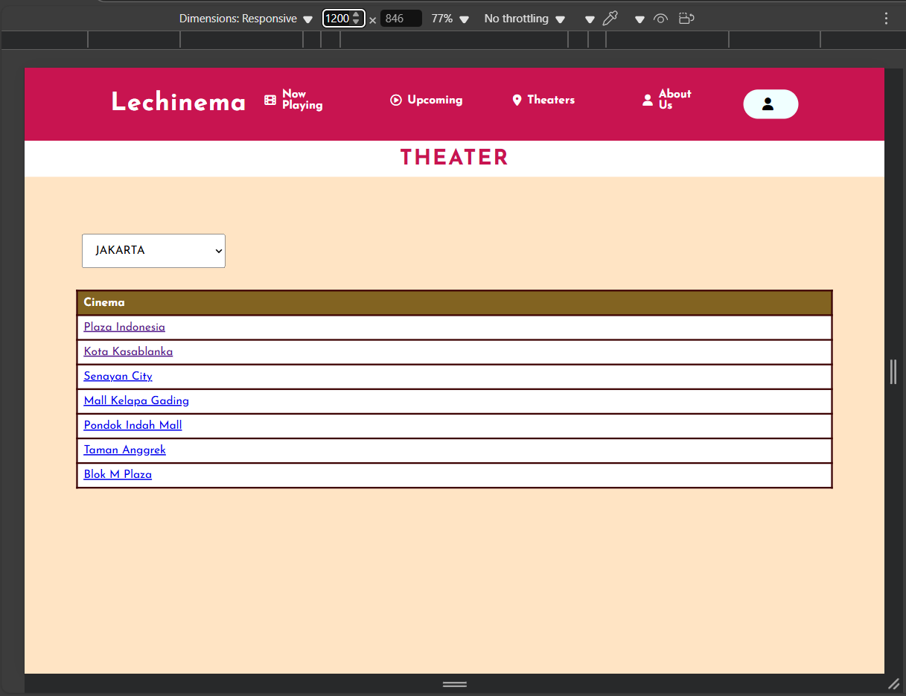

**RESPONSIVE COMPARISON**

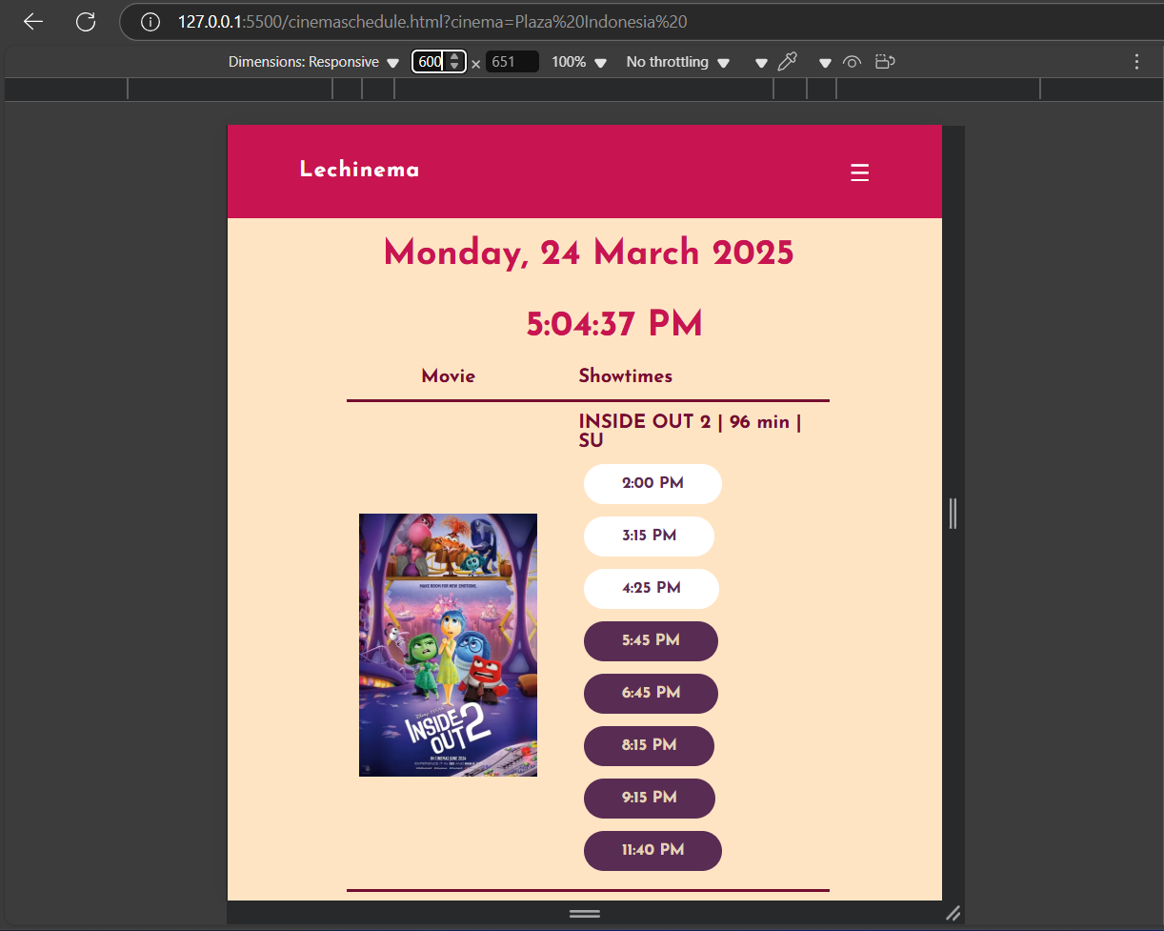 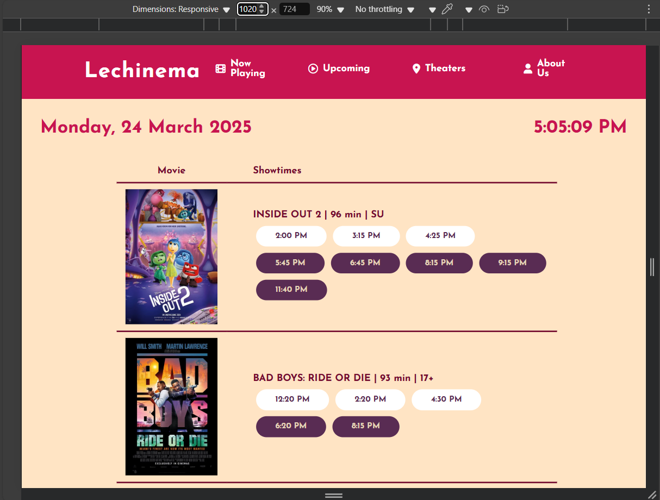

**RESPONSIVE COMPARISON**

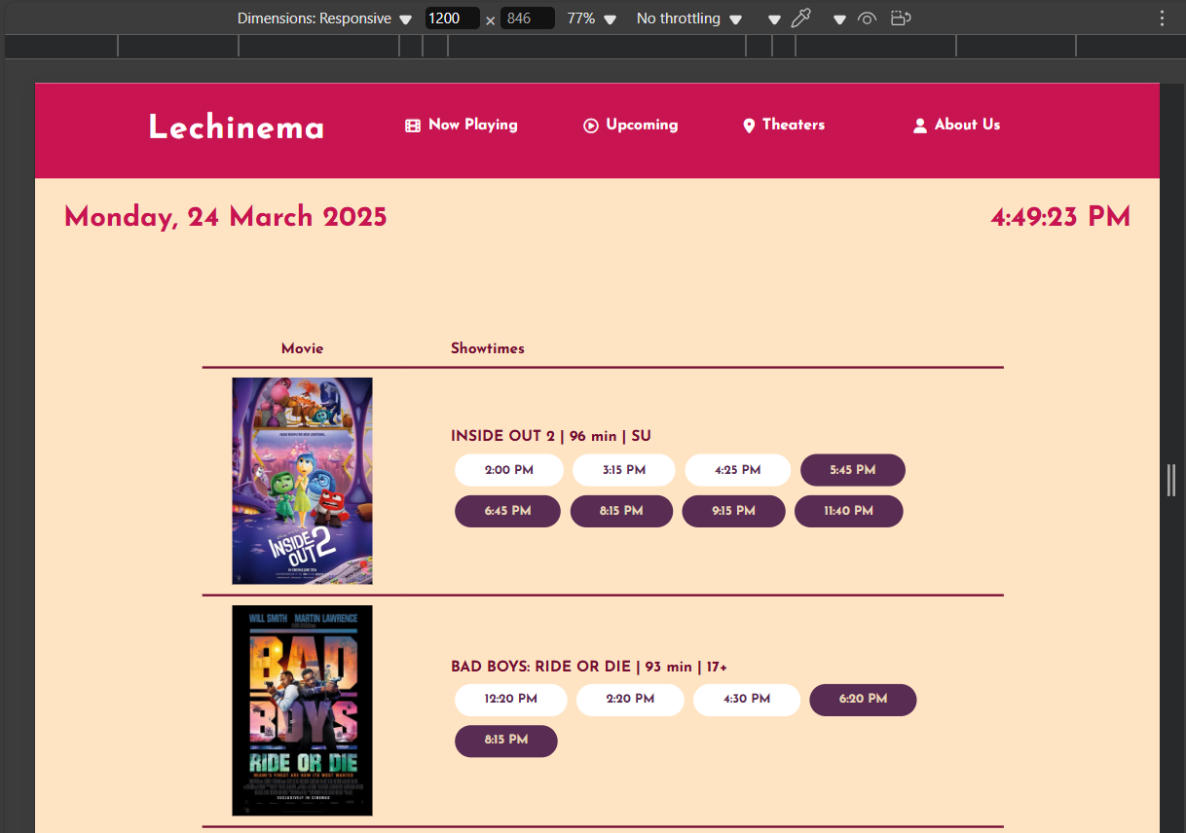 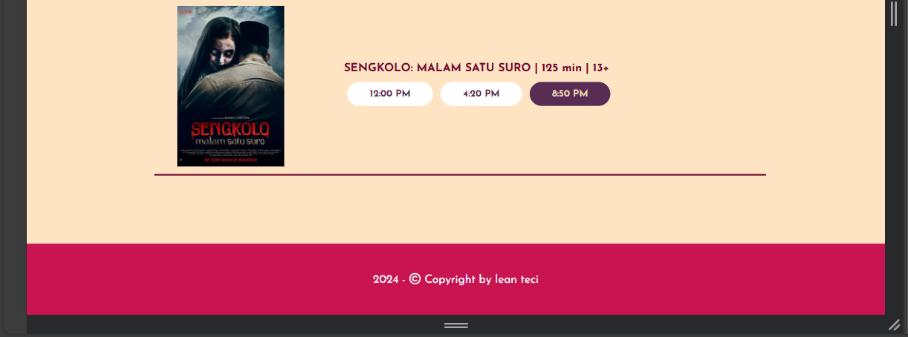

**RESPONSIVE COMPARISON**

**Footer**

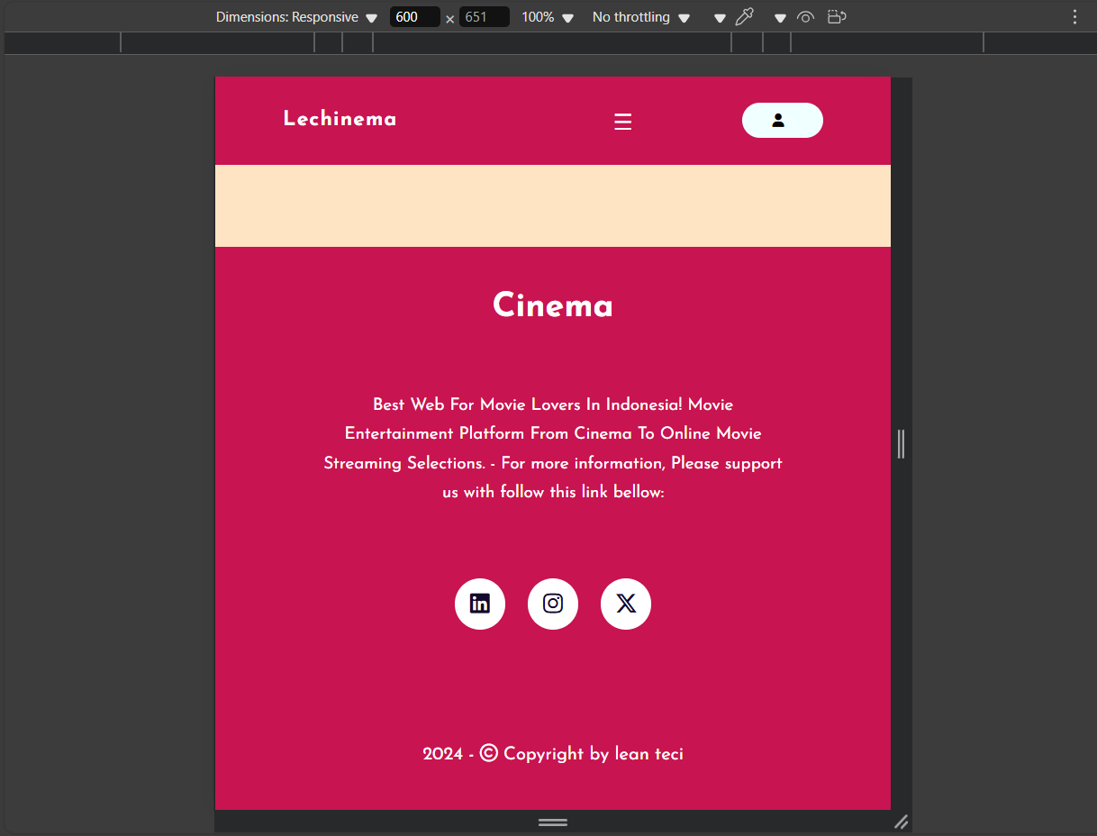 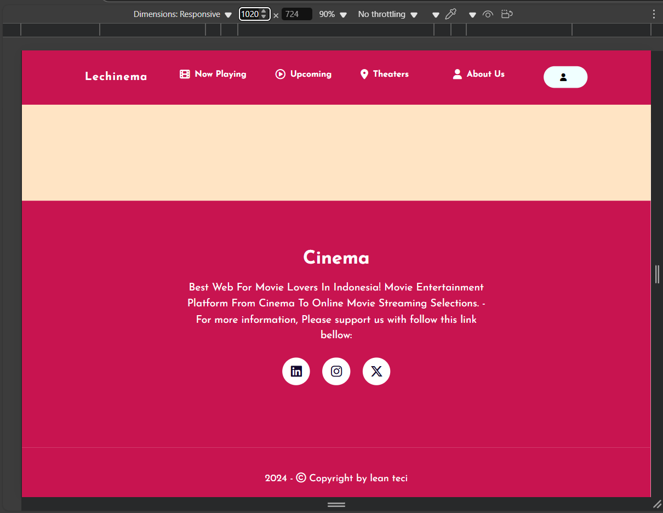

**RESPONSIVE COMPARISON**

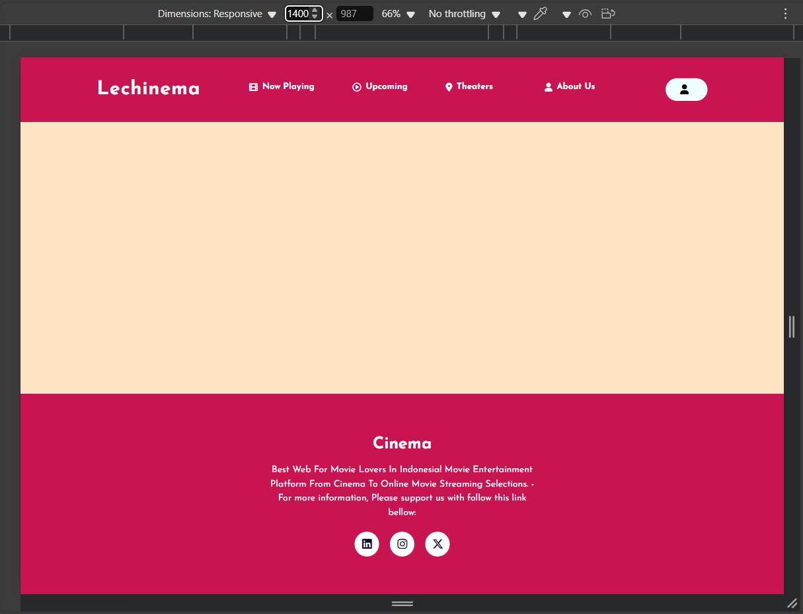

**CONFIGURATION**

**Hardware :** VivoBook_ASUSLaptop X509FJ_A509FJ   
**Processor :** Intel(R) Core(TM) i7-8565U CPU

**Installed RAM :** 8,00 GB  
**System type :** 64-bit operating system, x64-based processor  
**Operating System :** Windows 11 Home Single Language  
**Software :** Visual Studio Code, Microsoft Word, Microsoft Power Point

|  |  |  |
| --- | --- | --- |
| **PROJECT FILE DETAILS** | | |
| **No.** | **File Name** | **Remarks** |
| 1. | PROJECT 14 | This File is Contains All Source Code of Program (https://github.com/chimomile/Cinema-Landing-Page-Responsive.git) |
| 2. | [PROJECT 14]Real-Time Schedule Checking and Review System with Responsive Design for Online Cinema Tickets.pdf | The Paper of Our Project |
| 3. | [PROJECT 14]Real-Time Schedule Checking and Review System with Responsive Design for Online Cinema Tickets.pptx | The Power Point of Our Project |